Orderlist
If you want to order please use whatsapp 06-14563169.

Irish stewed beef pie | Pastry crust filled with stewed beef, vegetables in gravy. Weight apprx. 400 grms. | 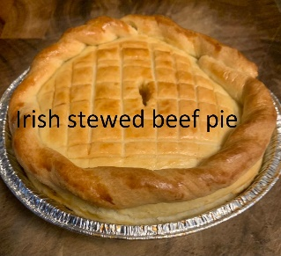 | € 7,50
Chicken and mushroom pie | Pastry crust filled with tender chicken, leeks and mushrooms in a creamy sauce. Weight apprx. 400 grms | 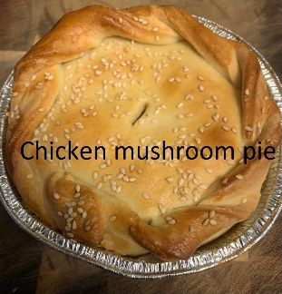 | € 7,00
Vegetable curry pie | Pastry crust filled with parsnip, carrot and mushrooms in a creamy curry sauce. Weight apprx. 400 grms | 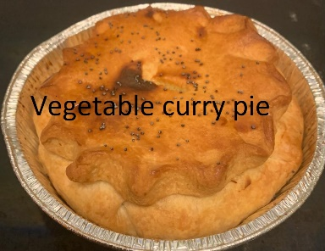 | € 6,00
Sticky toffee pudding | Toffee cake with a delicious homemade toffee sauce. | 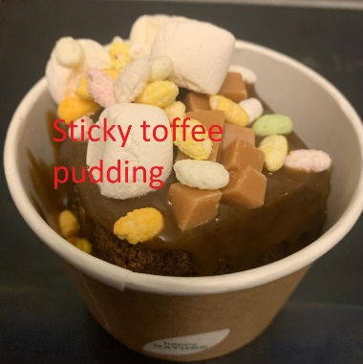 | € 3,50
Scone | Delicious English scone with clotted cream and jam | 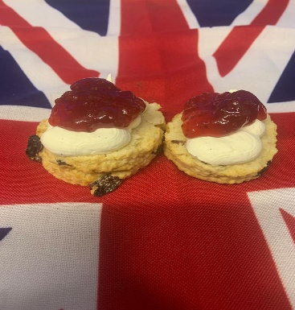 | € 3,50

